**MOTOR POWERED VEHICLE WITH BRIDGE PLACING CAPABILITIES**

**Team 5:**

Inventors: **Caleb Dooling**, Naperville, IL; **Morgan Valdez**, Washington, MI; **Ian Villaroman**, Westland, MI;

Filed: **November 10, 2015**

**ABSTRACT**

An autonomous vehicle is provided which consists of four wheels supported by two axles, the system is powered by DC motors controlling the rear wheels. The vehicle is capable of traveling down an incline, placing a bridge across a gap, crossing a bridge, retrieving the bridge, and traveling up an incline.

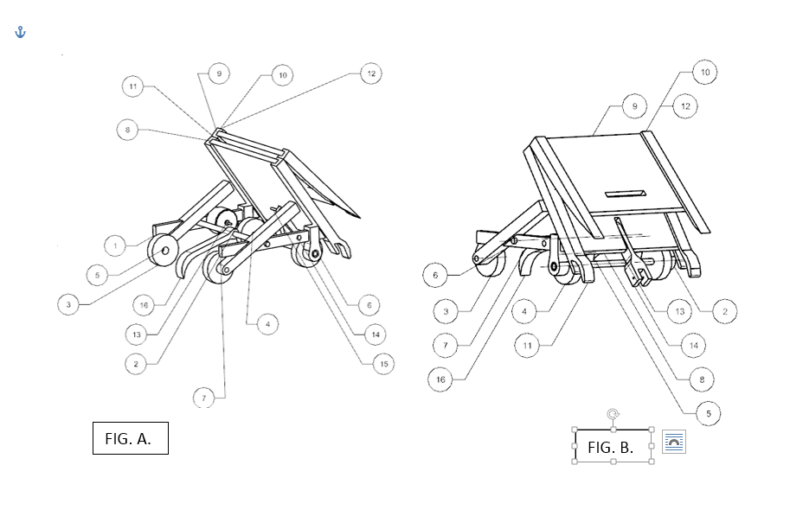z

**MOTOR POWERED VEHICLE WITH BRIDGE PLACING AND TRAVERSING CAPABILITIES**

FIELD OF INVENTION

The invention is similar to an autonomous vehicle capable of placing a bridge across a hazard such as a gap, crossing without failure, and collecting the bridge again.

BACKGROUND OF INVENTION

Vehicles constructed for the Build-a-Bridge competition required teams to design a vehicle capable of moving from Point A to Point B. Teams are given the option to have their invention be designed to retrieve its bridge before the completion of its goal. The vehicle presented is designed to deploy its bridge and complete the optional task of retrieving it as well in order to gain the advantage of having its course completion time halved.

In the context of this problem, the invention must be capable of traveling from point A to point B on the provided track. These points are separated by two inclines and a length of horizontal track. The horizontal piece of track contains a void that is longer than the vehicle and as wide as the track. The invention will descend the first incline, cross the void in the path, then continue on its path up the second incline. The invention must not use the sides of the track or the tops of the track’s railings in any way to traverse the void. All other methods of traversing the void are acceptable.

SUMMARY OF INVENTION

The invention is an autonomous transportation vehicle which consists of four wheels, the front two being driven. The vehicle is designed to transport itself across a gap via the deployment of a bridge member.

BRIEF DESCRIPTION OF THE DRAWINGS

FIG. A- Full assembly of full vehicle

Component name

1=Bottom bridge

2=Front wheel

3=Front Axle

4=Front vertical frame

5=Horizontal frame

6=Articulation rod

7=Center Axle

8=Rear wheel

9=Rear vertical frame

10=Support block

11= Top bridge

12=Articulation rod axle

13=Rear wheel half axles

DETAILED DESCRIPTION OF THE PREFERRED EMBODIMENT

DETAILED DESCRIPTION OF THE PREFERRED EMBODIMENT

Referring in more detail to the drawings, FIG. A. shows the vehicle powered by a front wheel drive system which would be powered by DC motors which are fixedly attached to a gear system that is fixedly attached to the front axle (3) which are fixedly attached to the front wheels(2). The front axle (3) is held in place by the front vertical frames (4) but allowed to rotate freely. The two front vertical frames (4) are connected to the rear vertical frames (9) by the two horizontal frames (5). The two frame halves are attached by the front axle (3) at the front vertical frames (4), and central axle (7) at the horizontal frames (5), and the support block (10) at the top of the rear vertical frame (9). The rear wheels (8) are attached opposite each other to their respective rear vertical frame (9) by the rear wheel half axles (13). The rear wheel half axles (13) are fixedly attached to the rear vertical frames (9) and the rear wheels (8) are able to rotate about the rear wheel half axles (13) freely. The bridge assembly rests on top the rear vertical frame (9) and the front vertical frame (4). The vehicle is powered by a single switch mounted to the rear vertical frame (9).

DRIVE SYSTEM

The vehicle is propelled through the use of a shaft which drives the front wheels. Which is powered by a single motor through a gear series designed to improve the motor’s torque output.

What is claimed is

1 A vehicle is comprised of autonomous chassis with integrated power source, running gear, control mechanisms, a traversion method, bridge-deploying assembly and cradle.

2 The vehicle’s bridge assembly makes use of a scouting wheel that will utilize gravity to automatically deploy the bridge in the presence of a gap.

3 The vehicle’s bridge consists of rails, assist spring, platforms, wheels, and shaft.

4 The opening of the bridge of claim 2 is assisted by a mechanical spring.

5 The rails of the bridge in claim 2 consist of two identical sets with the platforms suspended in between.

6 The pair of rails which, post deployment, are closest to the vehicle have an end feature which allows for them to securely set themselves against the edge of the void closest to the vehicle.

7 The pair of rails which, post deployment, are farthest from the vehicle have an end feature which allows for them to securely set themselves against the edge of the void farthest from the vehicle.

8 The vehicle of claim 1 employs a reclamation system to recollect the bridge assembly after its deployment and the traversing of the void.

OATH AND DECLARATION OF INVENTION

The individuals stated on the first page of this document under inventors, specified by location claim absolute responsibility of this design and all components and functions listed in accordance with the understanding that the invention entailed was designed to operate under specified limitations and within a set course of operation. Any similarities or comparable operations to other mechanisms were unbeknown to the inventors listed and will be held subject to the date of patent and details of specific operation and function.

Signed upon the 10th day of November 2015

Caleb Dooling

Morgan Valdez

Ian Villaroman

|  |  |
| --- | --- |
| **MOTOR POWERED VEHICLE WITH BRIDGE PLACING CAPABILITIES**  **Team 5:**  Inventors: **Caleb Dooling**, Naperville, IL; **Morgan Valdez**, Washington, MI; **Ian Villaroman**, Westland, MI;  Filed: **November 10, 2015**  **ABSTRACT**  An autonomous vehicle is provided which consists of four wheels supported by two axles, the system is powered by DC motors controlling the rear wheels. The vehicle is capable of traveling down an incline, placing a bridge across a gap, crossing a bridge, retrieving the bridge, and traveling up an incline.    FIG. A  vehicle is designed to transport itself  across a gap via the deployment of a bridge member.  BRIEF DESCRIPTION OF THE DRAWINGS  FIG. A- Full assembly of full vehicle  Component name  1=Bottom bridge  2=Front wheel  3=Front Axle  4=Front vertical frame  5=Horizontal frame  6=Articulation rod  7=Center Axle  8=Rear wheel  9=Rear vertical frame  10=Support block  11= Top bridge  12=Articulation rod axle  13=Rear wheel half axles  DETAILED DESCRIPTION OF THE PREFERRED EMBODIMENT  Referring in more detail to the drawings, FIG. A. shows the vehicle powered by a front wheel drive system which would be powered by DC motors which are fixedly attached to a gear system that is fixedly attached to the front axle (3) which are fixedly attached to the front wheels(2). The front axle (3) is held in place by the front vertical frames (4) but allowed to rotate freely. The two front vertical frames (4) are connected to the rear vertical frames (9) by the two horizontal frames (5). The two frame halves are attached by the front axle (3) at the front vertical frames (4), the articulation rod axle (12) and central axle (7) at the horizontal frames (5), and the support block (10) at the top of the rear vertical frame (9). The rear wheels (8) are attached opposite each other to their respective rear vertical frame (9) by the rear wheel half axles (13). The rear wheel  What is claimed is   1. A vehicle is comprised of autonomous chassis with integrated power source, running gear, control mechanisms, a traversion method, bridge-deploying assembly and cradle. 2. The vehicle of claim 1 contains a front wheel drive system consisting of two axles, fixed onto the vehicle’s chassis. 3. The vehicle of claim 1 contains a motor capable of delivering power to both wheels in an even split. 4. The bridge-deploying mechanism of claim 1 features a motor that will articulate a boom which will extend and lower the bridge for crossing 5. The vehicle’s bridge consists of a scouting wheel that enables the bridge to be deployed in the presence of a gap. 6. The vehicle’s bridge consists of platforms, wheels, and a shaft | **MOTOR POWERED VEHICLE WITH BRIDGE PLACING AND TRAVERSING CAPABILITIES**  FIELD OF INVENTION  The invention is similar to an autonomous vehicle capable of placing a bridge across a hazard such as a gap, crossing without failure, and collecting the bridge again.  BACKGROUND OF INVENTION  Vehicles constructed for the Build-a-Bridge competition required teams to design a vehicle capable of moving from Point A to Point B. Teams are given the option to have their invention be designed to retrieve its bridge before the completion of its goal. The vehicle presented is designed to deploy its bridge and complete the optional task of retrieving it as well in order to gain the advantage of having its course completion time halved.  In the context of this problem, the invention must be capable of traveling from point A to point B on the provided track. These points are separated by two inclines and a length of horizontal track. The horizontal piece of track contains a void that is longer than the vehicle and as wide as the track. The invention will descend the first incline, cross the void in the path, then continue on its path up the second incline. The invention must not use the sides of the track or the tops of the track’s railings in any way to traverse the void. All other methods of traversing the void are acceptable.    SUMMARY OF INVENTION  The invention is an autonomous transportation vehicle which consists of four wheels, the front two being driven. The  half axles (13) are fixedly attached to the rear vertical frames (9) and the rear wheels (8) are able to rotate about the rear wheel half axles (13) freely. The bridge assembly rests on top the rear vertical frame (9) and the front vertical frame (4). The bridge assembly is composed of a bottom bridge (1) and a top bridge (11) that moves in reaction to the articulation rod (6). The articulation rod (6) rotates about the articulation rod axle (12). The top bridge (11) will react to the force of the articulation rod (6) causing the top bridge (11) to gradually deploy in relation to the articulation rod’s (6) position. The top bridge’s (11) motion will meet the bottom bridge (1) causing the bottom bridge (1) to move together as a single assembly. The articulation rod (6) moves in a swivel-motion from the rear to the front of the vehicle. The vehicle is powered by a single switch mounted to the rear vertical frame (9).  DRIVE SYSTEM  The vehicle is propelled through the use of a shaft which drives the front wheels. Which is powered by a single motor through a gear series designed to improve the motor’s torque output.  OATH AND DECLARATION OF INVENTION  The individuals stated on the first page of this document under inventors, specified by location claim absolute responsibility of this design and all components and functions listed in accordance with the understanding that the invention entailed was designed to operate under specified limitations and within a set course of operation. Any similarities or comparable operations to other mechanisms were unbeknown to the inventors listed and will be held subject to the date of patent and details of specific operation and function.  Signed upon the 10th day of November 2015  Caleb Dooling  Morgan Valdez  Ian Villaroman |